|  |  |
| --- | --- |
| EX.NO:2 | CREATE A XHTML DOCUMENT TO IMPLEMENT TYPES OF CSS |
| DATE : 26.6.18 |

AIM:

To design a webpage using for resume using types of CSS.

PROCEDURE:

1. Create a file with .css extension and write the style codings inside it.

2. Create a file with .html extension and write the html codes inside it.

3. The .html file includes both internal and inline CSS and .css file for external CSS.

4. Save both the files in htdocs inside Xampp folder.

5. Display the output using Intranet hosting.

CODINGS:

EXTERNAL :

h2,h3

{

color: blue;

text-align: right;

}

h4,h5,h6,h7

{

color: gray;

text-align: left;

font-size: 30px;

}

h8,h9,h10,h11,h12,h13

{

color: gray;

text-align: left;

font-size: 30px;

}

table,th,td

{

border :1px solid black;

}

INTERNAL AND INLINE CSS

<html>

<head>

<link rel="stylesheet" type="text/css" href="format.css">

<style>

h1

{

color:maroon;

}

</style>

</head>

<body>

<h1><center><b>RESUME</b></center></h1>

<h2>bharathim.16it@kongu.edu</h2>

<h3>8220738547</h3>

<h4>Career objective</h4>

<p>Proficient at developing and testing hardware systems.

Expertise in a variety of computer and software tasks.

Proven ability to problem-solve while remaining calm.</p>

<h5> Qualification Details<h5>

<table>

<tr>

<th>year</th>

<th>Qualification</th>

<th>name of the institution</th>

<th>percentage</th>

</tr>

<tr>

<th>2014</th>

<th>sslc</th>

<th>The Spectrum Academy</th>

<th>89%</th>

</tr>

<tr>

<th>2016</th>

<th>hsc</th>

<th>The Little Angels Hr Sec School</th>

<th>92%</th>

</tr>

<tr>

<th>2020</th>

<th>b.tech</th>

<th> Kongu Engineering College</th>

<th>7</th>

</tr>

</table>

<h6>Skill Test</h6>

<p>c,c++,java</p>

<h7>Skill Test</h7>

<p>Data Structures</p>

<h8>Papers Presaented </h8>

<p>Presented a paper titled� INVISIBLE EYE"held at Madras Institute of Technology

,chennai</p>

<h9>Projects Done </h9>

<p>� DISEASE ALERT SYSTEM� in the Open House Exhibition held at Kongu Engineering College, Perundurai

</p>

<h10>Cocurricular Activities</h10>

<p> hackathon coding in my department function</p>

<h11>Responsibilities taken</h11>

<p> Member in IT Association</p>

<h12>Membership Details</h12>

<p> 1)Andriod Developement Club </p>

<p> 2) English Proficiency Club </p>

<p class="one"><b>PERSONAL PROFILE</b></p>

<div class= "clearfix">

<img class="img1" src="pic.jpg" alt="PHOTO" width="120" height="120">

<div class= "left">

<p> Name : Bharathi.M</p>

<p>Gender : Female</p>

<P> Mobile number : 8220738547

<p>e-mail address : bharathim.16it@kongu.du

</div>

</div>

<p>Date of Birth & Age : 08/04/1999& 19</p>

<p> Fathers name : Manivannan.B</p>

<p>Mothers name : Renuka.M</p>

<p>Nationality : Indian </p>

<p>Marital status : Single</p>

<p>Address : 3/82D ,Kurinji nagar,Mohanur road Namakkal</p>

<p>Languages Known : Tamil, English</p>

<p>Hobbies : playing shuttle</p>

<p class="one"><b>REFERENCE</b></p>

<p>Dr.S.Varadhaganapathy, M.S., M.E., Ph.D.,</p>

<p> Head of the Department,</p>

<p> Department of Information Technology,</p>

<p> Kongu Engineering College, </p>

<p> Perundurai, Erode � 638052.</p>

<p> Perundurai</p>

<p> 5.7.18</p>

<p><right>[Bharathi.M]</right></p>

</body>

</html>

OUTPUT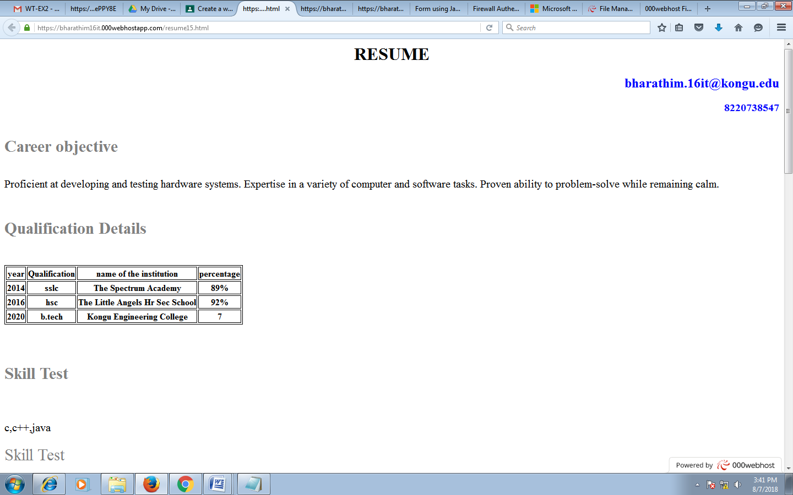

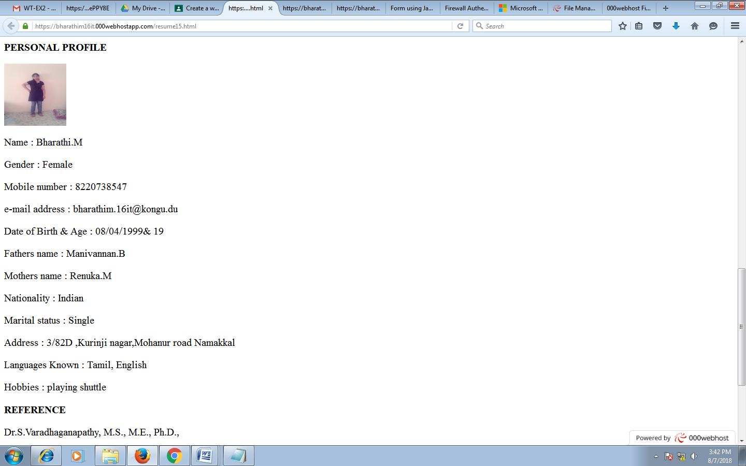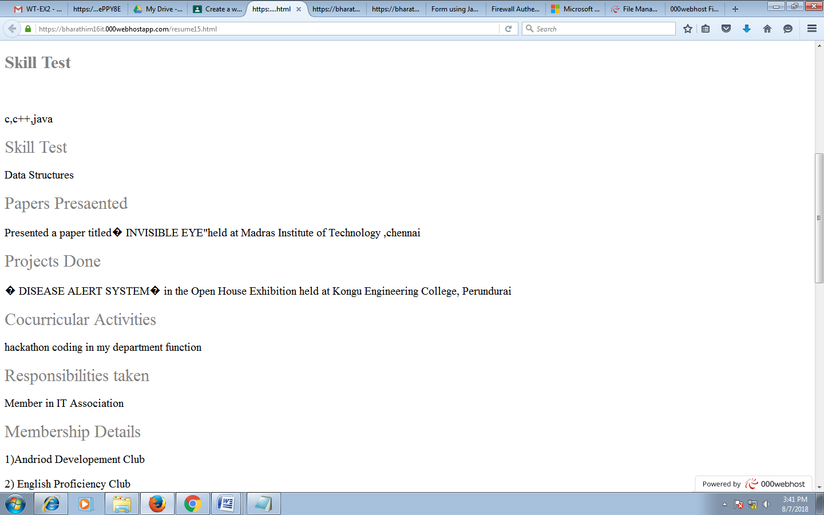

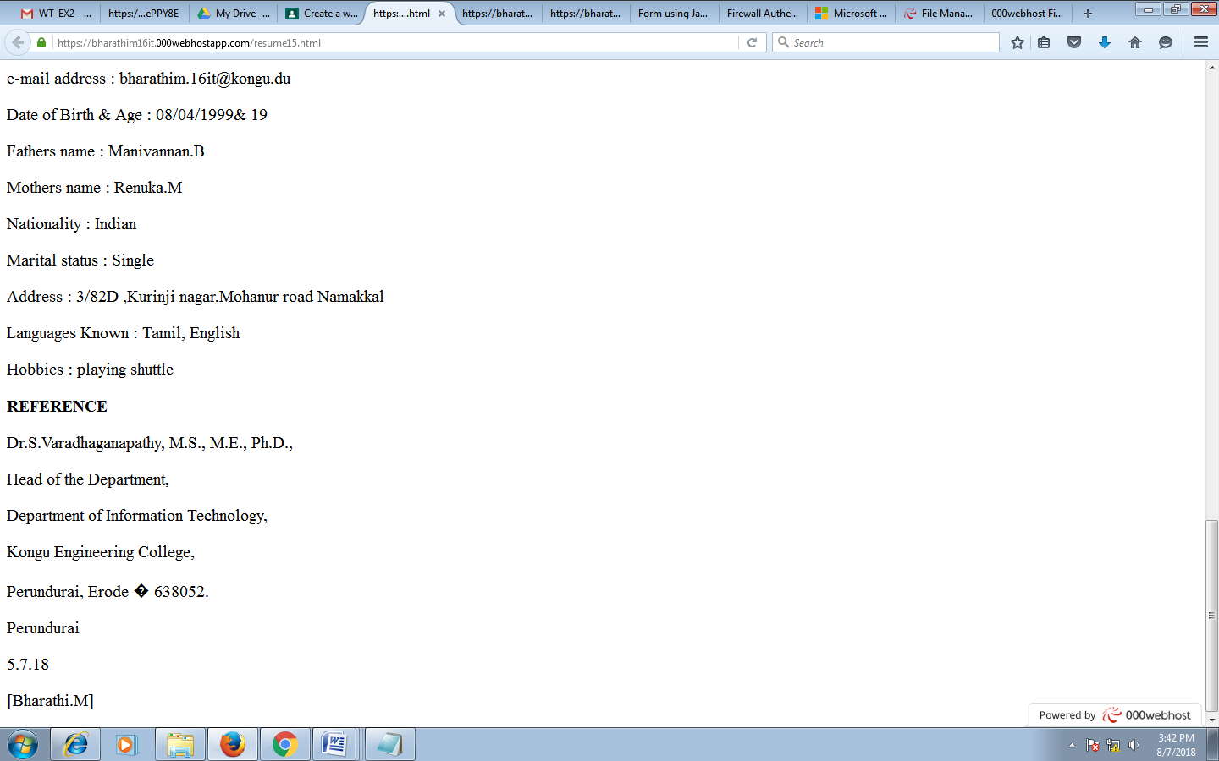

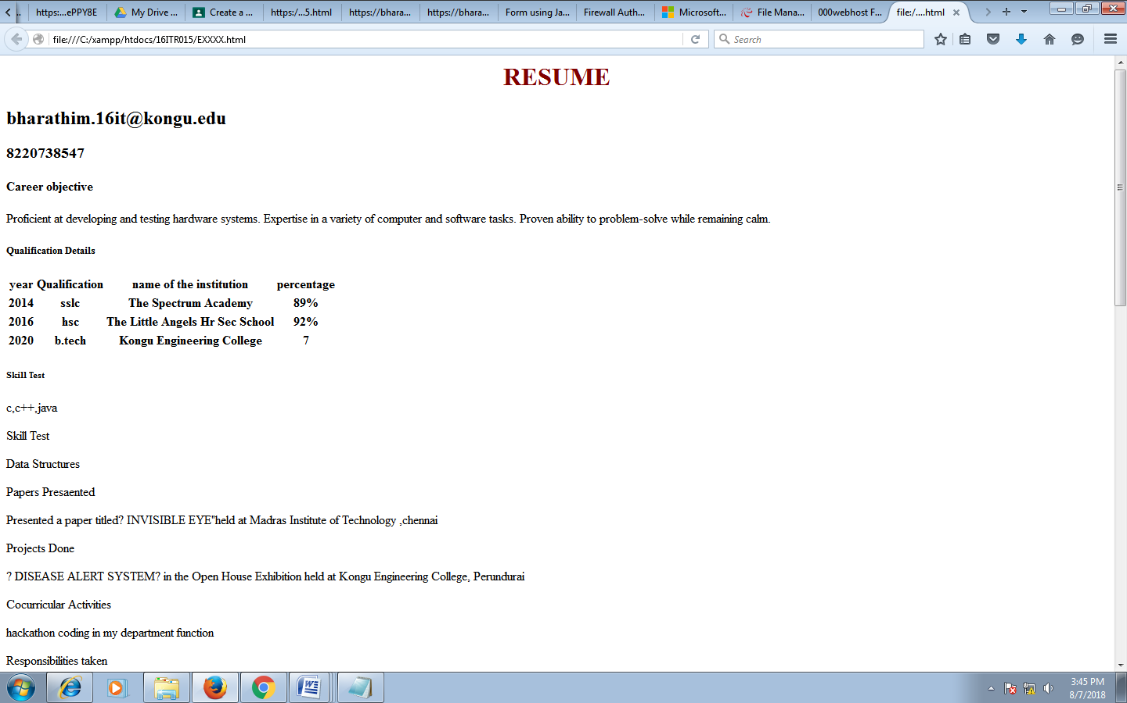

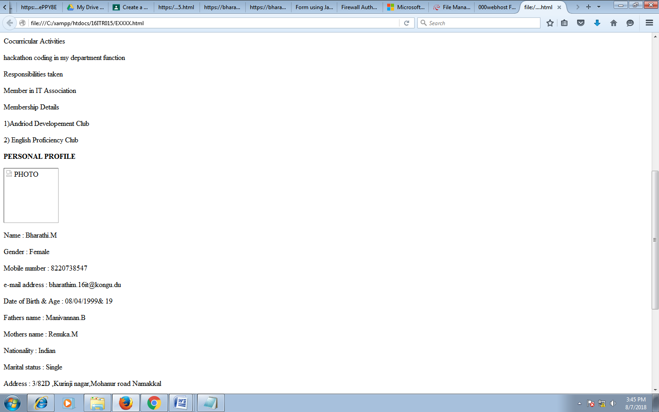

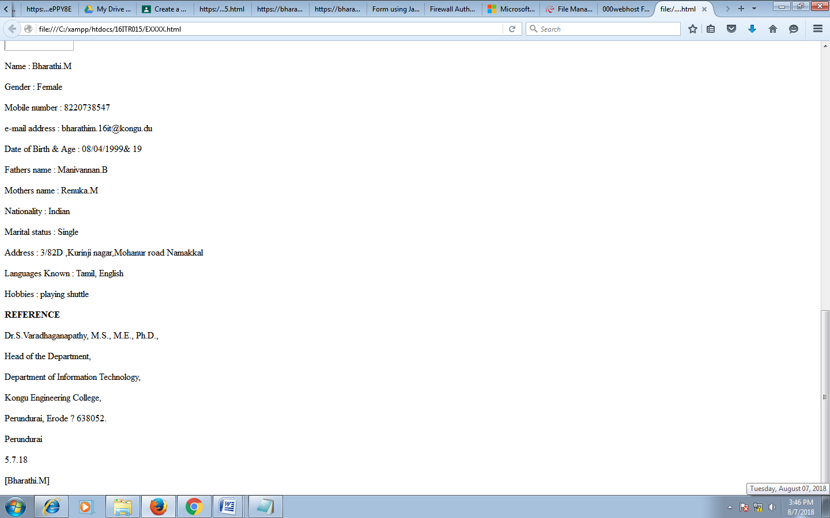

**RESULT :**

Thus the types of css was implemented successfully.